Vol. 59 No. 6 Upcoming Events!

June 7 –Summer Youth Series begins;.

We will be taking the bus to the Summer Youth Series this summer. If you are interested in going, please see Tim or Daria Parks!
Attention Youth Group

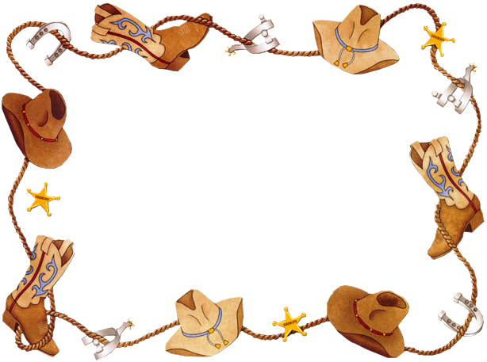
July 12 – We will host the Summer Youth Series.

You are invited to attend a
60th Anniversary Celebration for
Bo & Whiz Creighton
and an
80th Birthday Celebration for Bo
on
Sunday, June 6, 2021
2:00 pm-4:00 pm
at
Biardstown Community Center
164 CR 13685
Paris, TX

2) What was the name of the sons?
3) Why did Naomi decide to go back to Israel?
4) Who was Boaz, according to verse one?
5) In whose field did Ruth glean barley?
6) What did Boaz say to Ruth?

Donna Moseley
2810 Stillhouse Rd., Unit 201
Paris, TX 75462
Phone 903-669-5245

Let’s welcome Donna into our loving family here!


Trey Good
4200 Pine Mill Rd.
Paris, TX 75462
Phone 903-609-6288

Let Trey know how proud you are of his decision to become a child of God.

Scripture Reading Plan for June 2021

June 5 Ruth 1
June 6 Ruth 2
June 7 Ruth 3
June 8 Ruth 4
June 11 Ruth 1
June 12 Ruth 2
June 13 Ruth 3
June 14 Ruth 4
June 18 Ruth 1
June 19 Ruth 2
June 20 Ruth 3
June 21 Ruth 4
June 25 Ruth 1
June 26 Ruth 2
June 27 Ruth 3
June 28 Ruth 4

Questions:
1) At what time does the story of Ruth begin?
June 2021

Sunday Morning | 6 | 13 | 20 | 27
Scripture | SEE | NOLAN | BUTLER !
Read by | Mike Crews | Trey Good | Barron Killough | Wylie Dykes
Opening Prayer | Bobby Graves | Rick Zant | Michael Fry | Bobby Graves
Song Leader | Paul Payne | Bobby Graves | Kerry Dykes | Charlie Hodgkiss
Announcements | Bobby Graves | Rick Zant | Michael Fry | Bobby Graves
Lord’s Supper | N/A
 | N/A
 | N/A
 | N/A
 | N/A
 | N/A
Closing Prayer | Travis Ball | Wylie Dykes | Bo Creighton | Bradley Cochran
Usher | Craig Zant
Comm. Prep. | Communion packets are available in the foyer
Sound Board
Sunday Evening | 6 | 13 | 20 | 27
Opening Prayer | Joe Carpenter | Charlie Hodgkiss | Paul Payne | Mike Crews
Closing Prayer | Kerry Dykes | Jonas Butler | Tim Parks | James Weems
Wednesday | 2 | 9 | 16 | 23 | 30
Devotional | Summer Series | Summer Series | Summer Series | Summer Series | Summer Series
Week of | 6 | 13 | 20 | 27
Bus Driver | Craig Zant | James Weems | Ashley Grose | Sheri Arnold

Please remember these in your prayers: Our brethren in Mexico, Brenda Rodgers, Travis Palmer, military personnel, Breann Hargis (Connie Ball’s granddaughter), Phyllis Stanley (Laura Killough’s mother), Jean Perry, Norma Dalton, Candace McClain (Betty Eudy’s granddaughter), Dene Cochran, Kristi Hodgkiss (Charlie & Judy Hodgkiss’ sister-in-law).

.

periodical

June Birthdays
College Caller (USPS 852-240) is published monthly by the College church of Christ, P.O. Box 1426, Paris, TX 75461. Periodical postage paid at Paris, TX 75460 Postmaster: Send form 3579 to the College Caller, P.O. Box 1426, Paris, TX 75461

3 – Tawana Stewart
6 – Harley Kyle
7 – Roger Lough
8 – Bo Creighton
9 – Nancy Adams
9 – Billy Davis
13 – Billie Kyle
14 – Vermelle Kitkpatrick
18 – Jean McGee
23 – Rylee Adams
24 – Donna Perry
25 – Michael Fry
27 – Connie Ball

June Anniversaries
1 – Bo & Whiz Creighton
4 – Billy & Roxanne Fergurson
6 – Nolan & Victoria Butler
7 – Roy & Nancy Adams
12 – Bobby & Judy Graves
14 – Tim & Daria Parks
16 – Joe & Margie Carpenter
23 – Wylie & Cindy Dykes
23 – Archie & Merle Lynch
27- Cody & Leah Dykes



Sunday Bible Study 9:00 am
Worship 10:00 am
Worship 1:00 pm
KPLT Radio Program 96.3 FM 9:00 am

Wednesday
Bible Study 6:00 pm

Elders Michael Fry 903-732-5182
Bobby Graves 903-517-1669
Rick Zant 903-785-2381
Website www.collegechurchofchristparis.com
College Caller
A bulletin of the College church of Christ
1030 24th SE, Paris, TX 75460 (903) 785-2170
Mailing address: P.O. Box 1426, Paris, TX 75461-1426
June 2021

Inspiring
My
Soul
Wed. Night Summer Series
Beginning June 2, 2021
6:00 p.m.
6th grade – adult in auditorium
Bible Classes for
Babies thru 5th grade

Speakers

June 2…………David Ballard July 7………..…Brad Sullivan

June 9 …..……..John Cannon July 14. ………..Jerry Savage

June 16………...Evan Butler July 21 ………...Preston Boles

June 23………..Dwight Butler July 28.. ………Aaron Alsobrook

June 30………..Jeff Blanton August 4………Sage Bridges

