Vol. 58 No, 11 **Upcoming Events!**

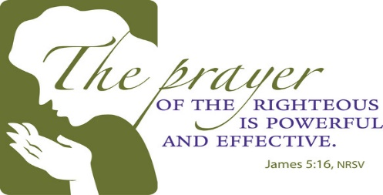

Please remember these in prayer: Our brethren in Mexico, Tuba City & Cameroon, Brenda Rodgers, Micah, Jennifer, Ava & Max Fry, Ann Mann, Donna Perry, Kara Kelley (Eddie & Renee Elmore’s daughter), Jean Perry, Donald & Becky Brown, R.L. Clark (former minister at Tudor St. church of Christ), Alan Parker, Charles Wilkerson (Cindy McGee’s father), Kristi Hodgkiss (Charlie & Judy Hodgkiss’ sister-in-law), Jean McGee, Jessica Perry, Oleta Lambert (Laura Graves’ grandmother), Les Stidham (Jessica Perry’s grandfather), Robert Ballard, Max & Carolyn Ballard, Andrea McDonald, Lyneil Beck, Billy Fergurson, Warren Skeen, Barbara Campbell, James Hawk, Martha Fox, Jean McGee.

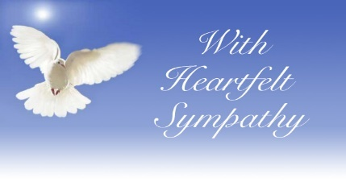

We extend our sympathy to Pam Fry, Rick Zant & Craig Zant on the loss of their uncle & to Edd Fry on the loss of his brother-in-law.

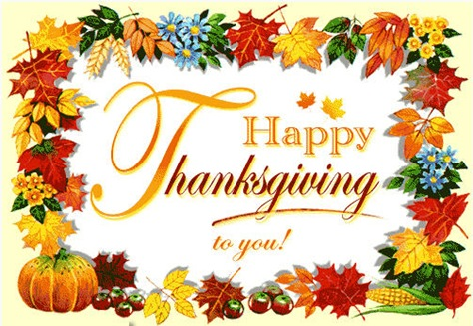

**Scripture Reading Plan for November 2020**

November 1 Leviticus 1, 1, 2

November 2 Leviticus 1, 2, 3

November 3 Leviticus 2, 3, 4

November 4 Leviticus 3, 4, 5

November 5 Leviticus 4, 5, 6

November 6 Leviticus 5, 6, 7

November 7 Leviticus 6, 7, 8

November 8 Leviticus 7, 8, 9

November 9 Leviticus 8, 9, 10

November 10 Leviticus 9, 10, 11

November 11 Leviticus 10, 11, 12

November 12 Leviticus 11, 12, 13

November 13 Leviticus 12, 13, 14

November 14 Leviticus 13, 14, 15

November 15 Leviticus 14, 15, 16

November 16 Leviticus 15, 16, 17

November 17 Leviticus 16, 17, 18

November 18 Leviticus 17, 18, 19

November 19 Leviticus 18, 19, 20

November 20 Leviticus 19, 20, 21

November 21 Leviticus 20, 21, 22

November 22 Leviticus 21, 22, 23

November 23 Leviticus 22, 23, 24

November 26 Leviticus 23, 24, 25

November 27 Leviticus 24, 25, 26

November 28 Leviticus 25, 26, 27

November 29 Leviticus 26, 27, 27

**Questions:**

1. How many chapters are there in the book of Leviticus?

2. What does the word 'Leviticus' mean?

3. Which book comes before the book of Leviticus in the Old Testament?

4. What is the first line in the book of Leviticus?

5. What does the book of Leviticus describe?

6. What is the name of God in the book of Leviticus?

7. Where does God talk to Moses in the book of Leviticus?

8. What should be put on a grain offering according to the book of Leviticus?

9. Who was the father of Mishael and Elzaphan?

10. Whose sons were consumed by fire?

11. What will happen to a man who marries his brother's wife according to the book of Leviticus?

12. How many days is a woman unclean after having a baby boy according to the book of Leviticus?

13. What will happen to a woman who is a wizard?

14. Who was told to tend the lamps outside the Tent of Meeting from evening till morning continually?

## A Psalm of Thanksgiving Dan Jenkins

The book of Psalms is remarkable in so many ways. Many of the psalms come from the heart of a shepherd boy of Bethlehem and give us great insight into the very soul of a man after God’s own heart.

One of the psalms repeats a phrase over and over. The psalmist said, “Oh, that men would give thanks to the Lord for His goodness, and for His wonderful works to the children of men” (Psa. 107:1, 8, 15, 21, 31). This phrase makes a natural division of five situations in this psalm where men should be filled with thanksgiving.

**Thanksgiving for redemption.**The first section (vss. 1-7) describes the times when God brought Israel from adversity and returned them to the land He promised Abraham’s descendants. While it is true the sin of God’s people often was the reason they were scattered, the psalm shows just how merciful God is toward His children. Those who were redeemed from the nations could so readily sing this psalm of thanksgiving.

**Thanksgiving for souls which have been refreshed.**In this section, the psalmist looks at the souls which have been brought low by the adversity around them. Their hearts are filled with darkness which is the result of ignoring God. They are bound up in affliction. Yet, when they cried out to God, He heard them. Their souls were filled with the blessing He gave to them. Their lives turned into joy because His mercy gave them what had been missing. The psalmist said, “Give thanks to the Lord for His wonderful works.”

**Thanksgiving for deliverance to those who were at the gates of death.**This third section (vss. 15-20) parallels thoughts found in the previous section of those who were surrounded by distress. They were so burdened they could not even eat, yet when they cried out to the Lord, He heard them and saved them out of all their afflictions. “Oh, that men would give thanks to the Lord for His goodness.”

**Thanksgiving from those who were tossed in the seas.**The psalmist turns his attention to those who sailed the seas and found themselves surrounded by tempestuous waves. As the waves lifted them to the heavens and then dropped them in the depths of the troughs, hope could so easily be lost. At their wit’s end, they cried out to God, and He heard them, calmed the storms and brought them to safe havens.

**Thanksgiving from those who assemble to worship in the company of the elders.**The mercy of God is shown in the fruitful seasons where He waters the wilderness and feeds His people. Their crops increase and their herds multiply. He exalts the poor. Oh, that men would give thanks for all He does.

**Thanksgiving from our hearts.**The imagery in this psalm is different from what is around us, but the lesson is so obvious. God help us to give thanksgiving for all He does!

periodical

College Caller (USPS 852-240) is published monthly by the College church of Christ, P.O. Box 1426, Paris, TX 75461. Periodical postage paid at Paris, TX 75460 Postmaster: Send form 3579 to the College Caller, P.O. Box 1426, Paris, TX 75461

November Birthdays

1 – Leah Dykes

2 – Merle Lynch

7 – Whiz Creighton

8 – Roy Adams

8 – Warren Skeen

9 – Dana Phillips

12 – Lynda Zant

15 – Rickey Brazeal

15 – Donald Brown

16 – Kenneth Proctor

18 – Judy Hodgkiss

19 – Sue Denton

19 – Larry Kyle

20 -- Charlie Thompson

22 – Cassi Weems

24 – Norma Dalton

26 -- William Campbell

27 – Sheri Arnold

27 – Bradley Cochran

28 – Eli Grose

30 – Myca Whitten

**November Anniversaries**

4 – Dale & Jane Henry

5 – Warren & Betsy Skeen

9 – Stephen & Sheri Arnold

20 – Korey & Jessica Perry

22 – Max & Carolyn Ballard

26 – Brent & Sherry Parson

29 – Carey & Tangy Clifton

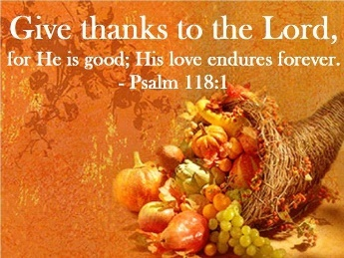

Sunday

Bible Study canceled at this time

Worship 10:00 am @ church bldg. & live on Facebook

Worship canceled at this time KPLT Radio Program 96.3 FM 9:00am

Wed. Bible Study 6:00 pm on Facebook

Elders Michael Fry 903-732-5182

Bobby Graves 903-517-1669

Rick Zant 903-785-2381

**Website: www.collegechurchofchristparis.com**

**College Caller**

A bulletin of the College church of Christ

1030 24th SE, Paris, TX 75460

Mailing address P.O. Box 1426, Paris, TX 75461

(903) 785-2170

November 2020

# Evidences of Christians

Words obviously have definitions and it is important to use words with a full understanding of what each word means. One of the problems which has led to religious division is a failure to define words of the New Testament as they were used in the first century. One would never come to the conclusion that sprinkling is baptism if we understood that the word “baptism” in the first century always meant “to dip, to submerge.”

I recall years ago when knocking doors in New Zealand that we asked the man who came to the door what he was religiously. He knew he was something but had no idea what he was. So he shouted out to his wife and asked her what he was. In the broadest sense, he might have said he was a Christian, but had no idea beyond that.

New Zealand was an amazing place in so many ways. They viewed themselves as being a Christian nation, but only 3% of the people regularly went to worship. Obviously almost no one in there sang praises to God. Few of them had Bibles and even fewer read the Bible regularly. Their absence from assemblies meant they rarely gave anything to God. The Lord’s Supper was rarely observed. There was little evidence in their lives of Christ, yet they saw themselves as a Christian nation.

If a doctor has no office, has no patients, prescribes no medicine, diagnoses no illness, does no medical exams, and receives no pay, *is he a doctor?*Whenever he has stopped doing those things which doctors do, he is no longer a doctor.

If a farmer plows no land, buys no seed, plants no crops, feeds no animals, never harvests anything, *is he a farmer?*Whenever he has stopped doing those things which farmers do, he is no longer a farmer.

Now make the spiritual application of this principle. If a Christian stops attending worship, sings no hymns of praise, never bows his head to pray with others, never gives, never reads the Bible, never sits in Bible classes or hears sermons, *is he a Christian?*Whenever he has stopped doing those things which Christians do, he is no longer a Christian.

Let me make this same point in another way. Suppose our government were overthrown and all Christians were put on trial. Those found guilty were immediately slain. If this were to happen, would there be enough evidence to convict you? Think about this, what evidence is there to those around you that you are a Christian? If Christianity were outlawed, would you be alive or dead.

Remember the words of Jesus: “Let your light so shine before men, that they may see your good works and glorify your Father.” Do others know that you are a Christian? --Dan Jenkins