Vol. 58 No… 8 Upcoming Events!

August 6 – First Responders Appreciation Lunch was hosted by our congregation. We fed approximately 100 first responders.


Please remember these in your prayers: Cristy Brazeal, our brethren in Mexico, Brenda Rodgers, Micah, Jennifer & Gus Fry, Breanna Hargis (Connie Ball’s granddaughter), Ann Mann, Donna Perry, Kara Kelley (Eddie & Renee Elmore’s daughter), students & teachers as they return to school, John Harris & Kimberly Harris (Dene Cochran’s grandson & daughter), Jean Perry, Donald & Becky Brown, R.L. Clark (former minister at Tudor St. church of Christ), Betty Eudy, Hunter Grose, Allen Parker, Charles Wilkerson (Cindy McGee’s father), Connie Ball, Kristi Hodgkiss (Charlie & Judy Hodgkiss’ sister-in-law), Cindy Dykes.

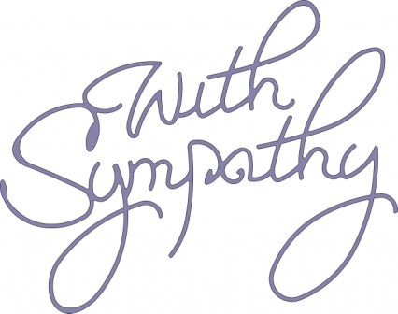
We extend our sympathy to David Brown on the loss of his daughter; to Stephen Arnold on the loss of his uncle; to Michael Fry on the loss of his uncle.

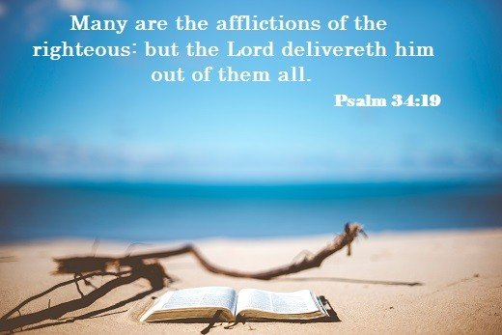


Kristen Parson
16321 FM 1499
Arthur City, TX 75411
Phone 903-732-8330

Be sure to welcome our new sister in Christ!

Scripture Reading Plan for August 2020
August 1 Genesis 26, 26, 27
August 2 Genesis 26, 27, 28
August 3 Genesis 27, 28, 29
August 4 Genesis 28, 29, 30
August 5 Genesis 29, 30, 31
August 6 Genesis 30, 31, 32
August 7 Genesis 31, 32, 33
August 8 Genesis 32, 33, 34
August 9 Genesis 33, 34, 35
August 10 Genesis 34, 35, 36
August 11 Genesis 35, 36, 37
August 12 Genesis 36, 37, 38
August 13 Genesis 37, 38, 39
August 14 Genesis 38, 39, 40
August 15 Genesis 39, 40, 41
August 16 Genesis 40, 41, 42
August 17 Genesis 41, 42, 43
August 18 Genesis 42, 43, 44
August 19 Genesis 43, 44, 45
August 20 Genesis 44, 45, 46
August 21 Genesis 45, 46, 47
August 22 Genesis 46, 47, 48
August 23 Genesis 47, 48, 49
August 24 Genesis 48, 49, 50
August 25 Genesis 49, 50, 50

Questions:

1. Who did Jacob marry first?

2. What was the name of Jacob and Leah’s daughter?

3. Why did Joseph’s brothers hate him?

4. Which of the two dreamers in prison with Joseph was executed?

5. Which of his brothers did Joseph put in jail to ensure the rest would return?
Duty or Delight
Thom Vaught
"The place God calls you to is the place where your deep gladness and the world’s deep hunger meet.” (Frederick Buechner)
We were recently touring a college campus and one of the professors mentioned this quote in reference to students finding their calling or vocation. The quote struck me because of its two-fold message about our service to God.
First is the message that our calling should bring us gladness. During our quarantine family devotionals, this idea has come up several times. We talked about how doing things merely out of a sense of duty is not enough. What do we do if our service to God and others is no longer filled with joy? Often, we look inwardly when that happens and try to motivate ourselves out of guilt and a sense of obligation. Although this can help us get through a difficult patch, when we find our motivation waning, it cannot see us through the marathon of a life devoted to Christ. If we are going to continue to serve out of joy, sometimes it may require us to find another way to serve. There is no shame in this because there are so many different ways, we can serve our God. If you haven’t found a way to serve that gives you joy or if you are struggling to find the joy in a service you have been performing for years then look for a new way to serve.
Second is the message that our calling is not self-serving; where our joy is the end goal. Our Lord calls us to be like Him in this life by serving rather than being served (Matthew 10:24-28). Just as Christ addressed the physical and spiritual needs of the world in the first century, we are called to address the needs of the world in the twenty-first century.
Times and methods may change but this message predates even the first century. As the writer of Psalm 100 noted to the children of Israel, they were to “Serve the Lord with gladness.” So, it remains the same today thousands of years later. What is so awesome about the quote inspiring this is that by finding the intersection of our joy and the world’s need we can serve God, fill a need of the world and satisfy one of our great needs at the same time. One of our great needs is a sense of purpose in this world. What many never learn is that purpose and meaning in this life come from serving others rather than themselves.
Perhaps you have never found this intersection of gladness and need, or maybe it is something you had but have lost. Keep looking and do not lose hope because there are innumerable good works for us to do to God’s glory (Ephesians 2:10). It is great to know that purpose in this life is not a question of duty versus delight because we can have both.

periodical

College Caller (USPS 852-240) is published monthly by the College church of Christ, P.O. Box 1426, Paris, TX 75461. Periodical postage paid at Paris, TX 75460 Postmaster: Send form 3579 to the College Caller, P.O. Box 1426 Paris, TX 75461.

August Birthdays
1 – Cristi Garst
8 – Travis Ball
9 – Betty Eudy
11 – Jill Hodgkiss
12 – Cindy Dykes
13 – Chance Booker
16 – Sherry Kyle
17 – Baran Killough
18 – Ryan Pickering
19 – Charlott Pickering
20 – Edd Fry
21 – Alyssa Parks
22 – Jay Dykes
24 – David Brown
25 – Jason Brown
25 – Pam Fry
27 – Janice Cochran

August Anniversaries
8 – Mark & Tawana Stewart
24 – Nick & Sally Becerra
24 – James & Cassi Weems
27 – Brad & Janice Cochran



Sunday Bible Study 9:00 am
Worship 10:00 am
Worship 5:00 pm
KPLT Radio Program 96.3 FM 9:00 am

Wednesday
Bible Study 6:00 pm

Elders Michael Fry 903-732-5182
Bobby Graves 903-517-1669
Rick Zant 903-785-2381
Website: www.collegechurchofchristparis.com
College Caller
A bulletin of the College church of Christ
1030 24th SE, Paris, TX 75460 (903) 785-2170
Mailing address: P.O. Box 1426, Paris, TX 75461-1426
August 2020



