Vol. 58 No, 1 Upcoming Events!

January 5 – First Sunday Fellowship following morning services. Evening services will be at 1:00. Bring your favorite foods & join in the fun.


Ladies’ Day
at College church of Christ
Saturday, February 1, 2020
9:30 a.m. – 1:00 p.m.
Tami Roberts, speaker
“Follow His Light”
Registration begins at 9:00 a.m.
A wonderful soup luncheon follows program.

Scripture Reading Plan for January 2020
January 2 Philippians 1, 1, 2
January 4 Philippians 1, 2, 3
January 10 Philippians 2, 3, 4
January 12 Philippians 3, 4, 4
January 16 Colossians 1, 1, 2
January 18 Colossians 1, 2 3
January 24 Colossians 2, 3, 4
January 26 Colossians 3, 4, 4

Questions:
- What did Paul tell the Philippians he desired?

- Why did Paul say to do everything without complaining or arguing?

- What is the destiny of those who live as enemies of Jesus?

- What did Paul say transcends all understanding and will guard our hearts and minds in Jesus?

- Who is the image of the invisible God, the firstborn over all creation?

- In who are all the treasures of wisdom and knowledge hidden?

- In what should God’s people clothe themselves?

To Start A New Year
Anonymous
"A new year is unfolding—like a blossom with petals curled tightly concealing the beauty within.
Lord, let this year be filled with the things that are truly good—with the comfort of warmth in our relationships, with the strength to help those who need our help and the humility and openness to accept help from others.
As we make our resolutions for the year ahead, let us go forward with great hope that all things can be possible—with Your help and guidance."

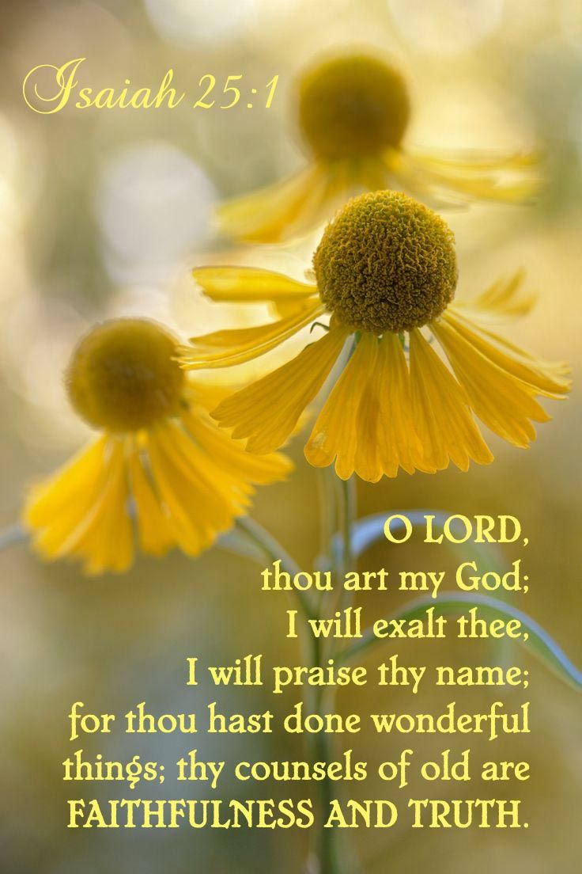
January 2020

Sunday Morning | 5 | 12 | 19 | 26
Scripture | SEE | NOLAN | BUTLER !
Read by | Kaleb Ball | Eddie Elmore | Kerry Dykes | Jeff Ballard
Opening Prayer | Paul Payne | Billy Fergurson | Rick Zant | James Weems
Song Leader | Stephen Arnold | Kerry Dykes | Wylie Dykes | Bobby Graves
Announcements | Michael Fry | Bobby Graves | Rick Zant | Michael Fry
Lord’s Supper | Joe Carpenter
 | Wylie Dykes
 | Baran Killough
 | David Hagler
 | William Campbell
 | Michael Fry
Closing Prayer | Bradley Cochran | Travis Ball | Levi Weems | Stephen Arnold
Usher | Eric Woods
Comm. Prep. | Travis & Amy Ball
Sound Board | Jonas Butler
Sunday Evening | 5 | 12 | 19 | 26
Opening Prayer | Joe Carpenter | Wylie Dykes | Charlie Thompson | William Campbell
Closing Prayer | Mike Whitten | Jonas Butler | Tim Parks | Baran Killough
Wednesday | 1 | 8 | 15 | 22 | 29
Devotional | Paul Payne | Rick Zant | Bobby Graves | Michael Fry | Charlie Hodgkiss
Week of | 5 | 12 | 19 | 26
Bus Driver | Dale Perry | Tim Parks | Craig Zant | James Weems

Please remember these in your prayers: Cristy Brazeal, our brethren in Mexico, those serving in the military, Brenda Rodgers, Gus, Micah & Jennifer Fry, Breanna Hargis (Connie Ball’s granddaughter), Jamie Parker, Donna Perry, Charles & Margaret Wilkerson (Cindy McGee’s parents), Ann Mann, our brethren in White Settlement, TX, Jeff Ballard, Max Ballard, Phyllis Hagler.

periodical

College Caller (USPS 852-240) is published monthly by the College church of Christ, P.O. Box 1426, Paris, TX 75461. Periodical postage paid at Paris, TX 75460 Postmaster: Send form 3579 to the College Caller, PO Box 1426, Paris, TX 75461.

January Birthdays
3 – Billy Rodgers
7 – Tangy Clifton
7 – Randalyn Kyle
10 – Blake Ballard
10 – Elizabeth Fry
10 – Ashley Grose
11 – Jaxon Dykes
11 – Chad Graves
12 – Eddie Elmore
12 – Margaret Lough
13 – Renee Elmore
15 – Preslee Cochran
15 – Paul Payne
17 – Rhealie Brazeal
22 – Bailee Adams
24 – Levi Weems
30 – Hunter Grose

January Anniversaries
1 – Mike & Myca Whitten
15 – Michael & Pam Fry
25 – William & Barbara Campbell



Sunday Bible Study 9:00am
Worship 10:00am
Worship 5:00pm KPLT Radio Program 96.3 FM 9:00am

Wednesday
Bible Study 6:00pm

Elders Michael Fry 903-732-5182
Bobby Graves 903-517-1669
Rick Zant 903-785-2381

Website www.collegechurchofchristparis.com
College Caller
A bulletin of the College church of Christ
1030-24th S.E., Paris, TX 75460
Mailing address: P.O. Box 1426, Paris, TX 75461-1426
(903) 785-2170
January 2020

Together We Grow
As we consider needed changes in the year ahead, we should examine the frequency with which we attend opportunities for worship and Bible study. There are two extremes associated with the subject of church attendance. The first is looking for a minimum weekly requirement and the second settles on human tradition as binding authority.
Scripture teaches that congregations of the Lord’s people must meet on the first day of the week to worship the Lord (Acts 20:7; 1 Cor. 16:2; Heb, 10:25). The Scripture is silent concerning meeting times and duration of services. Through the centuries these matters have changed according to the needs and circumstances of the day. In a primitive agricultural setting, Sunday services might have been an all-day affair with dinner on the grounds. No Sunday or Wednesday night services. Today we have Bible classes prior to Sunday morning worship services. Sunday evening services seem to have originated as a result of more and more people having jobs that required them to work on Sunday morning. Our Wednesday evening Bible classes used to be mid-week prayer meetings.
Other than meeting with the church on the Lord’s Day for the purpose of engaging in the five acts of worship, the scheduled meetings of the church fall into the area of expediency. As our shepherds, the elders are responsible to feed the flock over which they exercise oversight (1 Pet. 5:1-3; Acts 20:28). There are different ways the elders can make sure the church is being spiritually fed. They can go from house to house teaching the flock or, because of time limitations, it may be expedient for them to ask the church to gather for special feedings from God’s word. These meetings include Sunday morning Bible classes, Sunday evening services, and Wednesday night classes. From time to time, our shepherds provide other opportunities such as gospel meetings, VBS, seminars, and retreats. Our participation in these opportunities not only demonstrates love and devotion for God and one another; it also shows respect for God’s leadership in the church.
Attendance is not a matter of following tradition or seeking the minimum required devotion in order to stand right with God. If being together for study and worship is merely something we do because we have to do it, then we have altogether missed the point. Early Christians met daily “devoting themselves to the apostles’ teaching and to fellowship, to the breaking of bread and to prayer” (Acts 2:42). They had no church buildings. They had no church bulletin. They had no appointed time for mid-week Bible study. They had singleness of mind and devotion to learn more and more of God’s word. May God richly bless us to this end.
Glen Elliott

