Vol. 57 No, 11 **Upcoming Events!**

**November 3 –** First Sunday Fellowship following morning service. Bring your favorite foods and join in the fun! Evening services will be at 1:00 p.m.

**DON’T FORGET…**to turn your clocks back on Nov. 2nd.

To everyone who helped make the table treating/chili eating such a success! Everyone had a wonderful time!

We extend our sympathy to to Ken Robbins on the loss of his brother.



[This Photo](http://www.flickr.com/photos/sarahmiskelly/2617180308/) by Unknown Author is licensed under [CC BY-NC-ND](https://creativecommons.org/licenses/by-nc-nd/3.0/)



**Bo & Whiz Creighton are the proud great-grandparents to Ali J. Creighton, born on July 26th. Proud parents are Cody & Lindsay Creighton & proud grandparents are Quint & Wendy Creighton.**

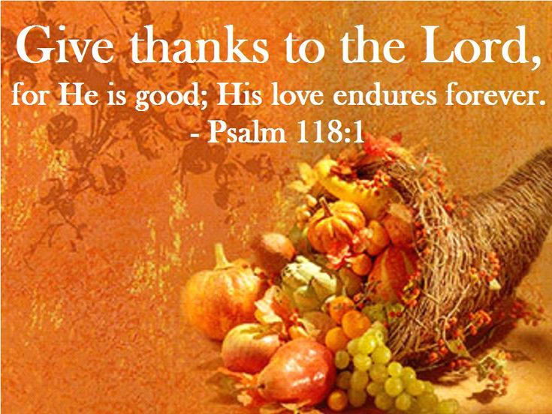

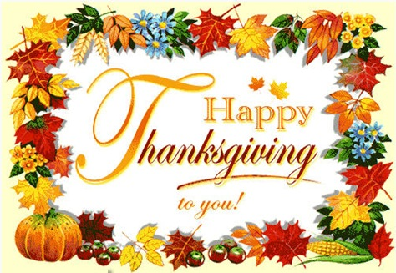

**Scripture Reading Plan for November 2019**

November 1 2 Corinthians 1, 1, 2

November 2 2 Corinthians 1, 2, 3

November 3 2 Corinthians 2, 3, 4

November 4 2 Corinthians 3, 4, 5

November 8 2 Corinthians 4, 5, 6

November 9 2 Corinthians 5, 6, 7

November 10 2 Corinthians 6, 7, 8

November 15 2 Corinthians 7, 8, 9

November 16 2 Corinthians 8, 9, 10

November 17 2 Corinthians 9, 10, 11

November 18 2 Corinthians 10, 11, 12

November 22 2 Corinthians 11, 12, 13

November 23 2 Corinthians 12, 13, 13

**Questions:**

1. How did Paul describe God?
2. In what spirit did Paul determine not to come to the Corinthian church again?
3. What did Paul consider to be his epistle?
4. Where did Paul’s sufficiency come from?
5. Who did Paul preach about?
6. What can a person give?
7. What attitude in giving does God love?
8. Who does Paul say is approved?
9. What experience did Paul describe?
10. What manifestations of God did Paul desire to be with the Corinthians?

November 2019

|  |  |  |  |  |  |
| --- | --- | --- | --- | --- | --- |
| Sunday Morning | 3 | 10 | 17 | 24 |  |
| Scripture | SEE | NOLAN | BUTLER ! |  |  |
| Read by | Levi Weems | Craig Zant | Michael Fry | Wylie Dykes |  |
| Opening Prayer | William Campbell | Bobby Graves | James Weems | Joe Carpenter |  |
| Song Leader | Bobby Graves | Paul Payne | Mike Whitten | Stephen Arnold |  |
| Announcements | Michael Fry | Bobby Graves | Rick Zant | Michael Fry |  |
| Lord’s Supper | Mike Whitten | | | | |
|  | Stephen Arnold | | | | |
|  | Jonas Butler | | | | |
|  | Bradley Cochran | | | | |
|  | Kerry Dykes | | | | |
|  | Hunter Grose | | | | |
| Closing Prayer | Travis Ball | Tim Parks | Ken Robbins | Billy Fergurson |  |
| Usher | Bobby Graves | | | | |
| Comm. Prep. | Michael & Pam Fry | | | | |
| Sound Board | Ryan Pickering | | | | |
| Sunday Evening | 3 | 10 | 17 | 24 |  |
| Opening Prayer | Paul Payne | Charlie Hodgkiss | Rick Zant | Charlie Thompson |  |
| Closing Prayer | Stephen Arnold | Chad Graves | Jonas Butler | Baran Killough |  |
|  | | | | | |
| Wednesday | 6 | 13 | 20 | 27 |  |
| Devotional | Charlie Hodgkiss | Charlie Thompson | Paul Payne | Thanksgiving Devo |  |
| Week of | 3 | 10 | 17 | 24 |  |
| Bus Driver | James Weems | Ashley Grose | Sheri Arnold | Dale Perry |  |

Please remember these in your prayers: Cristy Brazeal, our brethren in Mexico, those serving in the military, Brenda Rodgers, Micah, Jennifer & Gus Fry, Travis Palmer, Breanna Hargis (Connie Ball’s granddaughter), Ramey Moore (Ken & Betty Robbins’ son-in-law), Ann Mann, Roy Adams, Jamie Parker, Charlie Thompson.

periodical

College Caller (USPS 852-240) is published monthly by the College church of Christ, P.O. Box 1426, Paris, TX 75461. Periodical postage paid at Paris, TX 75460 Postmaster: Send form 3579 to the College Caller, P.O. Box 1426, Paris, TX 75461

November Birthdays

1 – Leah Dykes

2 – Merle Lynch

2 – Nora Pridemore

7 – Whiz Creighton

8 – Roy Adams

8 – Warren Skeen

9 – Dana Phillips

12 – Lynda Zant

15 – Betsy Townsend

15 – Rickey Brazeal

15 – Donald Brown

16 – Kenneth Proctor

18 – Judy Hodgkiss

19 – Sue Denton

19 – Larry Kyle

20 -- Charlie Thompson

22 – Cassi Weems

24 – Norma Dalton

26 -- William Campbell

27 – Sheri Arnold

27 – Bradley Cochran

28 – Eli Grose

30 – Myca Whitten

**November Anniversaries**

4 – Dale & Jane Henry

5 – Warren & Betsy Skeen

9 – Stephen & Sheri Arnold

12 – Cary & Megan Lindsey

20 – Korey & Jessica Perry

22 – Max & Carolyn Ballard

26 – Brent & Sherry Parson

29 – Carey & Tangy Clifton

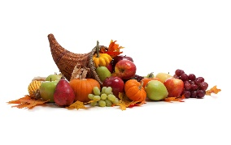

Sunday

Bible Study 9:00 am

Worship 10:00 am

Worship 5:00 pm KPLT Radio Program 96.3 FM 9:00am

Wed. Bible Study 6:00pm

Elders Michael Fry 903-732-5182

Bobby Graves 903-517-1669

Rick Zant 903-785-2381

**Website: www.collegechurchofchristparis.com**

**College Caller**

A bulletin of the College church of Christ

1030 24th SE, Paris, TX 75460

Mailing address P.O. Box 1426, Paris, TX 75461

(903) 785-2170

November 2019

Thanksgiving

Throughout the Bible, we see **thanksgiving** for blessings as a theme.  The Old Testament resounds with the people praising God; Israel had a history of giving thanks to God for the mercy and deliverance he showed them.   In the New Testament we read, Jesus "Then he took the five loaves and the two fish, and looking up to heaven he gave thanks and broke them" ([Luke 9:16](http://biblia.com/bible/nkjv/Luke%209.16)).  At the Last Supper Jesus took bread and gave thanks, and offered it to His followers ([1 Cor. 11:24](http://biblia.com/bible/nkjv/1%20Cor.%2011.24)).  Jesus always prayed before meals.

With the holiday approaching, let’s consider some thoughts for thanksgiving.

**Motive**.  When we give thanks to God, our sole motive should be pure gratitude.  Thanksgiving is giving thanks and that alone.  Of all our types of prayers, a thanksgiving prayer is the least likely to be polluted or corrupted with selfish thoughts or a subconscious appeal to manipulate God.  It is about God’s blessings toward us and our appreciation of those blessings.

**Knowledgeable**.  Being grateful requires us to look back into the past, whether times recent or years past, and acknowledging blessings for which we are thankful.   Our culture is infatuated with the future and the result is that thanksgiving is sometimes neglected.  But to give thanks to God is to look backwards, not forwards, and to express gratitude for the good things that have come our way.

**Comprehensive**.  On the U.S. holiday, we thank God for the meal.  Sometimes we include more in our prayers.  We should, because we are so blessed.  God is to be thanked for our family, friends, housing, jobs, and possibly hundreds of other minor things.  Giving God thanks should be a theme running through our lives in times good and bad.  The Pilgrims lived close enough to the soil to know how dependent they were on God's providence.  In bitter winters with scarce food, they learned to thank God for all they had.  And they were eager to thank Him during times of abundant blessing, too.

As Thanksgiving Day approaches, ponder and consider the many blessings you enjoy. Be grateful for these wonderful benefits and thank God for them. (borrowed)