Vol. 57 No… 9 Upcoming Events!

September 1 – First Sunday Fellowship immediately following morning services. Bring your favorite foods & join in the fun! Evening services will be at 1:00.

September 7 – Ladies’ Day at Blossom church of Christ with Nancy Wheat speaking on “Contentment”. Registration begins at 8:30 a.m. Lunch will be served.

September 28 – Ladies’ Day at Howe church of Christ with Yvonne Butler speaking on “Life is a Masquerade—Time to Unmask””. Registration at 9:00 a.m. Lunch will be served.



Please remember these in your prayers: Our brethren in Mexico, Brenda Rodgers, Travis Palmer, Micah, Jennifer & Gus Fry, Colleen Eudy, Courtney Mathews (Eddie & Renee Elmore’s daughter).


Scripture Reading Plan for September 2019

September 1 Romans 1, 1, 2
September 2 Romans 1, 2, 3
September 6 Romans 2, 3, 4
September 7 Romans 3, 4, 5
September 8 Romans 4, 5, 6
September 13 Romans 5, 6, 7
September 14 Romans 6, 7, 8
September 15 Romans 7, 8, 9
September 20 Romans 8, 9, 10
September 21 Romans 9, 10, 11
September 22 Romans 10, 11, 12
September 23 Romans 11, 12, 13
September 27 Romans 12, 13, 14
September 28 Romans 13, 14, 15
September 29 Romans 14, 15, 16
September 30 Romans 15, 16, 16

Questions:

- According to Paul writing through the inspiration of God who do we condemn when we pass judgment on someone else?
- How does God demonstrate his own love for us?
- Who is the end of the law so that there may be righteousness for everyone who believes?
- What do Christians have through endurance and the encouragement of the Scriptures?
- Which people are not serving our Lord Christ, but only their own appetites?
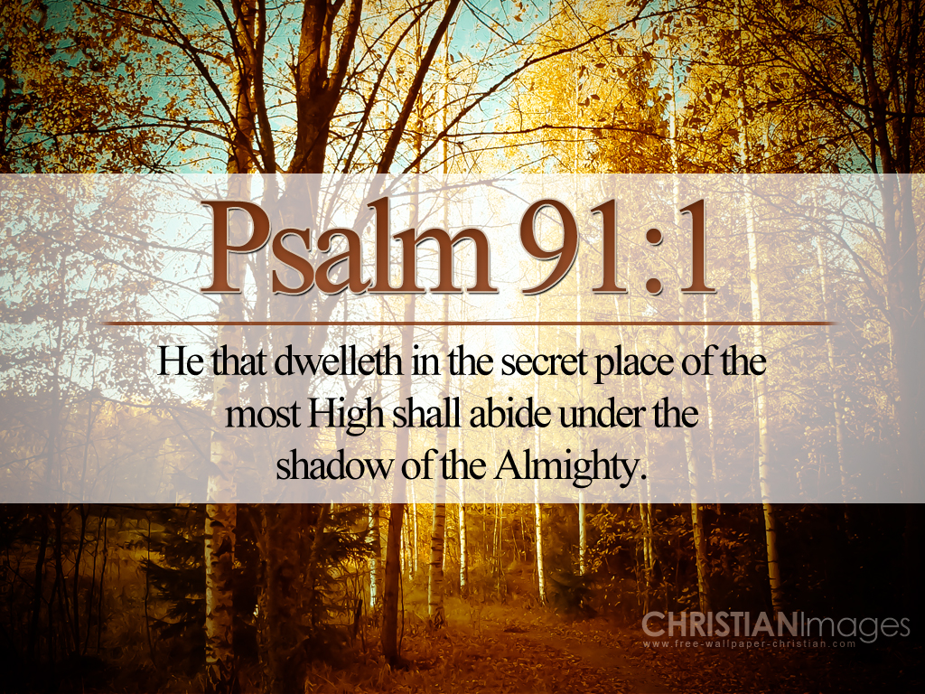
September 2019

Sunday Morning | 1 | 8 | 15 | 22 | 29
Scripture | SEE | NOLAN | BUTLER !
Read by | Mike Whitten | Baran Killough | Stephen Arnold | Travis Ball | Rick Zant
Opening Prayer | William Campbell | Charlie Hodgkiss | Billy Fergurson | Bo Creighton | Charlie Thompson
Song Leader | Stephen Arnold | Kerry Dykes | Wylie Dykes | Bobby Graves | Charlie Hodgkiss
Announcements | Michael Fry | Bobby Graves | Rick Zant | Michael Fry | Bobby Graves
Lord’s Supper | James Weems
 | Chad Graves
 | Kaleb Ball
 | Charlie Hodgkiss
 | Craig Zant
 | Levi Weems
Closing Prayer | Travis Ball | Paul Payne | Eddie Don Pickering | Kerry Dykes | Bradley Cochran
Usher | Eddie Elmore
Comm. Prep. | Tim & Daria Parks
Sound Board | Jonas Butler
Sunday Evening | 1 | 8 | 15 | 22 | 29
Opening Prayer | Joe Carpenter | Wylie Dykes | Bobby Graves | Michael Fry | Rick Zant
Closing Prayer | Tim Parks | Stephen Arnold | Hunter Grose | Ken Robbins | Mike Whitten
Wednesday | 4 | 11 | 18 | 25
Devotional | Rick Zant | Bobby Graves | Michael Fry | Charlie Hodgkiss
Week of | 1 | 8 | 15 | 22 | 29
Bus Driver | Tim Parks | Craig Zant | Lynda Zant | James Weems | Ashley Grose

periodical

College Caller (USPS 852-240) is published monthly by the College church of Christ, P.O. Box 1426 Paris, TX 75461-1426. Periodical postage paid at Paris, TX 75460 Postmaster: Send form 3579 to the College Caller, P.O. Box 1426, Paris, TX 75461-1426

September Birthdays
5 – Amy Ball
5 – Amelia Butler
5 – Patti Ballard
7 – Val Spiller
10 – Chuck Skeen
10 – Nick Becerra
11 – Carolyn Ballard
14 – Cody Dykes
15 – Cristy Brazeal
16 – Max Ballard
17 – Tristion Gandy
18 – Tuff Brazeal
18 – Jane Henry
18 – Laura Killough
20 – Ophelia Payne
23 – Jessica Perry
24 – Bonnie Keys
26 – Mary Huff
30 – Dale Henry

September Anniversaries
5 – Thomas & Jean McGee
13 – Kenneth & Inelda Proctor



Sunday Bible Study 9:00 am
Worship 10:00 am
Worship 5:00 pm
KPLT Radio Program 96.3 FM 9:00 am

Wednesday
Bible Study 6:00 pm

Elders Michael Fry 903- 732-5182
Bobby Graves 903-517-1669
Rick Zant 903-785-2381
Website: www.collegechurchofchristparis.com
College Caller
A bulletin of the College church of Christ
1030 24th SE, Paris, TX 75460 (903) 785-2170
Mailing address: P.O. Box 1426, Paris, TX 75461-1426
September 2019

America’s New Kind of God
Dan Jenkins

The events which followed the fall of the northern kingdom of Israel are recorded in the seventeenth chapter of
Second Kings. The Assyrians moved many of the Jews, who were part of Israel, and sent them throughout the
Assyrian world. Then, they brought men from other nations and settled them in Israel. This was an attempt, largely successful, to destroy the ethnicity of the Jews.

There was a problem when all of this happened. The Gentiles who came into the Promised Land brought their own gods and worshiped them. The anger of the Lord was stirred against this use of His land. “Therefore the Lord sent lions among them, which killed some of them” (v. 25). So, the king of Assyria understood the reason for the problem and said the lions “...are killing them because they do not know the rituals of the God of the land” (v. 26). His solution was to find a Jewish priest and send him to Bethel to teach them how to fear God (v. 28).

What was the result of all of this? “They feared the Lord, yet served their own gods—according to the rituals of the nations...they did not obey, but they followed their formal rituals...so the nations feared the Lord, yet served their carved images” (vs. 33, 40, 41).

What happened in that land is happening in our own land. Those people of the fallen northern kingdom did not like what they had been taught about the God in whose land they now dwelt. They simply redefined the God of Israel and ignored what He had said. Perhaps their fear of the lions was greater than their fear of the Lion of Israel. It is obvious they accepted some of the “rituals” of Judaism but brought in a new god they defined. The actual truth about that situation is found in verse thirty-four. “They do not fear the Lord, nor do they follow...the commandment which the Lord commanded.” Isn’t this is what is happening in our land?

We have redefined God and, while ritualistically following Him in some ways, we are serving our newly defined God! Think of all that is happening with the elevation of our own ideas. God’s view of marriage has been laid aside, and the “new God” accepts our own definitions of marriage. God’s view of worship being centered on all humbly praising Him has been replaced with worship that is man-centered and is designed to make us feel spiritual. The applause is given to Christian entertainers instead of reverence directed toward heaven. Look at all of Christendom and see if we are not doing as those in Israel.

It is high time for our nation, and us individually, to truly fear God and keep His commandments.

