Vol. 56 No. 5 **Upcoming Events!**

**May 5** – Senior Banquet honoring our high school graduates. This will be after our 5:00 evening service. We **will not** be having our usual first Sunday fellowship. The meat will be provided. Bring vegetables, salads, desserts & drinks.

**May 19 –** Elders & Deacons meeting at 3:30 p.m. If you have anything to discuss let them know.



**Huge thank you to the LTC Participants, coaches, supporters, parents & grandparents. A special thank you to Charlie Hodgkiss for his amazing organizational skills! This congregation is blessed with youth who represent us well!**

 Congratulations to Brittany Lindsey on her graduation from Southern Arkansas University on May 3rd.



To Connie Ball on the loss of her nephew.



**Scripture Reading Plan for May 2019**

May 1 Mark 1, 1, 2

May 2 Mark 1, 2, 3

May 3 Mark 2, 3, 4

May 7 Mark 3, 4, 5

May 8 Mark 4, 5, 6

May 9 Mark 5, 6, 7

May 14 Mark 6, 7, 8

May 15 Mark 7, 8, 9

May 16 Mark 8, 9, 10

May 21 Mark 9, 10, 11

May 22 Mark 10, 11, 12

May 23 Mark 11, 12, 13

May 24 Mark 12, 13, 14

May 28 Mark 13, 14, 15

May 29 Mark 14, 15, 16

May 30 Mark 15, 16, 16

**Questions:**

1. Who came baptizing in the desert region and preaching a baptism of repentance for the forgiveness of sins?
2. What did the Pharisees plan with the Herodians?
3. Who did Jesus give authority over evil spirits?
4. What did Peter, James and John witness high on the mountain?
5. Who said Love the Lord your God with all your heart and with all your soul and with all your mind and with all your strength and Love your neighbor as yourself?
6. What is the meaning of "Eloi, Eloi, lama sabachthani?"



May 2019

|  |  |  |  |  |  |
| --- | --- | --- | --- | --- | --- |
| Sunday Morning | 5 | 12 | 19 | 26 |  |
| Scripture | SEE | NOLAN | BUTLER ! |  |  |
| Read by | Levi Weems | Craig Zant | Kerry Dykes | Wylie Dykes |  |
| Opening Prayer | Joe Carpenter | Billy Fergurson | James Weems | Charlie Thompson |  |
| Song Leader | Kerry Dykes | Wylie Dykes | Bobby Graves | Charlie Hodgkiss |  |
| Announcements | Bobby Graves | Rick Zant | Michael Fry | Bobby Graves |  |
| Lord’s Supper | Eddie Elmore | | | | |
|  | Jason Brown | | | | |
|  | Chesley Phillips | | | | |
|  | Eddie Don Pickering | | | | |
|  | Ryan Pickering | | | | |
|  | Dalton Phillips | | | | |
| Closing Prayer | Levi Weems | Ken Robbins | Bradley Cochran | Travis Ball |  |
| Usher | Bobby Graves | | | | |
| Comm. Prep. | Bobby & Judy Graves | | | | |
| Sound Board | Tim Parks | | | | |
| Sunday Evening | 5 | 12 | 19 | 26 |  |
| Opening Prayer | Paul Payne | Rick Zant | William Campbell | Charlie Hodgkiss |  |
| Closing Prayer | Chad Graves | Tim Parks | Stephen Arnold | Mike Whitten |  |
|  | | | | | |
| Wednesday | 1 | 8 | 15 | 22 | 29 |
| Devotional | Rick Zant | Bobby Graves | Michael Fry | Charlie Hodgkiss | Charlie Thompson |

Please remember these in your prayers: Cristy Brazeal, our brethren in Mexico, military personnel, Brenda Rodgers, Travis Palmer, Micah, Jennifer & Gus Fry, Val Spiller, high school graduates, Warren & Betsy Skeen, Courtney Mathews (Eddie & Renee Elmore’s daughter), Charlie & Ruth Thompson, Ann Mann, teachers & students as they continue testing.

periodical

College Caller (USPS 852-240) is published monthly by the College church of Christ, P.O. Box 1426, Paris, TX 75461. Periodical postage paid at Paris, TX 75460 Postmaster: Send form 3579 to the College Caller, P.O. Box 1426 Paris, TX 75461

May Birthdays

2 – Becky Brown

2 – April Fergurson

4 – Eddie Don Pickering

5 – Bertha Smith

6 – Margie Carpenter

8 – Colton Booker

9 – Carla Fendley

10 – Chloe Graves

11 – Ken Robbins

13 – Victoria Butler

14 – Kelsea Ball

14 – Jimmie Avinger

15 – Ron Martin

22 – Stephen Arnold

23 – Kaleb Ball

27 – Syble Harbison

28 – Shawn Brown

29 –Chesley Phillips

31 – Kaydence Perry



Sunday Bible Study 9:00 am

Worship 10:00 am

Worship 5:00 pm

KPLT Radio Program 96.3 FM 9:00 am

Wednesday

Bible Study 6:00 pm

Elders Michael Fry 903-732-5182

Bobby Graves 903-517-1669

Rick Zant 903-785-2381

**Website** [**www.collegechurchofchristparis.com**](http://www.collegechurchofchristparis.com)

**College Caller**

A bulletin of the College church of Christ

1030-24th SE, Paris, TX 75460 (903) 785-2170

Mailing address: P.O. Box 1426, Paris, TX 75461-1426

May 2019

 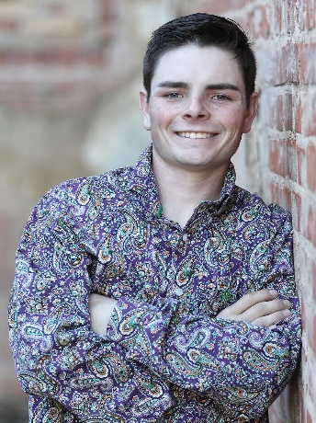

Amelia Butler Trey Good

Honey Grove High School Chisum High School



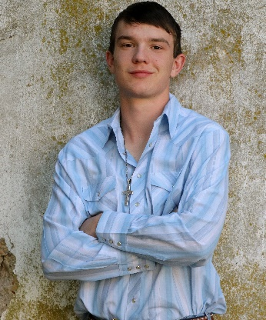 

Hunter Grose C.J. Weems

Trinity Christian Academy Chisum High School