Vol. 54 No, 11 Upcoming Events!

November 5 – Youth Devo at Tim & Daria Parks’ home at 5:00 p.m.

November 6 – First Sunday Fellowship following morning service. Bring your favorite foods and join in the fun! Evening services will be at 1:00 p.m.

November 20 – Elders & Deacons meeting at 3:30 p.m. If you have anything to discuss, let them know.

November 20 – Thanksgiving meal at 3:15 p.m. hosted by our Young Girls’ Class. Please sign the sheet in the foyer if you plan to attend.

November 23 – Annual Cookie Baking for all the youth. Meet at the church building at 4:00 p.m.



DON’T FORGET…to turn your clocks back on Nov. 5th.

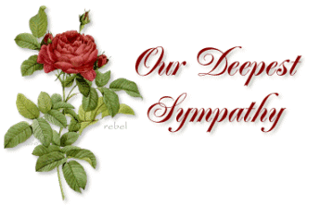
To Laura Graves on the loss of her grandfather.

Scripture Reading Plan for November 2016

November1 1 Chronicles 1, 1, 2
November2 1 Chronicles 1, 2, 3
November3 1 Chronicles 2, 3, 4
November4 1 Chronicles 3, 4, 5
November5 1 Chronicles 4, 5, 6
November6 1 Chronicles 5, 6, 7
November7 1 Chronicles 6, 7, 8
November8 1 Chronicles 7, 8, 9
November9 1 Chronicles 8, 9, 10
November10 1 Chronicles 9, 10, 11
November11 1 Chronicles 10, 11, 12
November12 1 Chronicles 11, 12, 13
November13 1 Chronicles 12, 13, 14
November14 1 Chronicles 13, 14, 15
November15 1 Chronicles 14, 15, 16
November16 1 Chronicles 15, 16, 17
November17 1 Chronicles 16, 17, 18
November18 1 Chronicles 17, 18, 19
November19 1 Chronicles 18, 19, 20
November20 1 Chronicles 19, 20, 21
November21 1 Chronicles 20, 21, 22
November22 1 Chronicles 21, 22, 23
November23 1 Chronicles 22, 23, 24
November24 1 Chronicles 23, 24, 25
November25 1 Chronicles 24, 25, 26
November26 1 Chronicles 25, 26, 27
November27 1 Chronicles 26, 27, 28
November28 1 Chronicles 27, 28, 29
November29 1 Chronicles 28, 29, 29

Questions:
1) Who is the first person listed in the genealogical records in verse one?
2) Who were the sons of Israel?
3) Who were the sons of David in these verses of this book?
4) What is Jabez remembered for in these verses of this book?
5) Who was the firstborn son of Israel, and what did he do that dishonored his name?
6) Who was the father of Moses?
7) How many sons did Issachar have, according to verse one of this book?
8) Who was the first born of Benjamin, according to verse one of this book?
9) Why were the people of Judah taken into captivity?
10) Who were the enemies of Israel who fought against them in these verses?
11) Why were the leaders of Israel comfortable with David becoming king?
12) What does this passage tell us about David’s development as a powerful king?
13) What project did David undertake?
14) What did Hiram, king of Tyre, send to David in verse one of this book?
15) Where did David want to bring the ark of the Lord to in verse one of this book?
November 2016

Sunday Morning | 6 | 13 | 20 | 27
Scripture | SEE | NOLAN | BUTLER !
Read by | Chad Graves | Ken Robbins | Jason Cunningham | Kevin Wood
Opening Prayer | Charlie Hodgkiss | Joe Carpenter | Paul Payne | Bobby Graves
Song Leader | Paul Payne | Stephen Arnold | Sheradon Carter | Jason Cunningham
Announcements | Michael Fry | Bobby Graves | Rick Zant | Michael Fry
Lord’s Supper | Dale Henry
 | Bradley Cochran
 | Max Ballard
 | Eric Woods
 | Stephen Arnold
 | David Brown
Closing Prayer | Travis Ball | Sheradon Carter | Jason Cunningham | Dalton Phillips
Usher | John Nash
Comm. Prep. | Michael & Pam Fry
Sound Board | Eddie Don Pickering
Sunday Evening | 6 | 13 | 20 | 27
Opening Prayer | Wylie Dykes | Charlie Thompson | Rick Zant | Michael Fry
Closing Prayer | Ken Robbins | J.R. Butler | Hunter Grose | Junior Oliver
Wednesday | 2 | 9 | 16 | 23 | 30
Devotional | Rick Zant | Bobby Graves | Michael Fry | Charlie Hodgkiss | William Campbell

Please remember these in your prayers: Cristy Brazeal, Lola Purser, our brethren in Mexico, those serving in the military, Brenda Rodgers, Micah, Jennifer & Gus Fry, James & Wynetta Carter, Travis Palmer, Breann Hargie (Connie Ball’s granddaughter), Courtney Mathews, Jamie Parker, Ginger Rater, Jim & Val Spiller, Roxanne Fergurson, Sue Denton, the election.

periodical

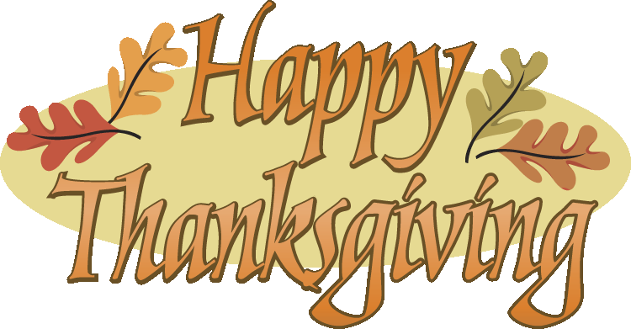

College Caller (USPS 852-240) is published monthly by the College church of Christ, P.O. Box 1426, Paris, TX 75461. Periodical postage paid at Paris, TX 75460 Postmaster: Send form 3579 to the College Caller, P.O. Box 1426, Paris, TX 75461

November Birthdays
1 – Margie Davis
1 – Leah Dykes
2 – Merle Lynch
2 – Nora Pridemore
7 – Whiz Creighton
8 – Roy Adams
8 – Warren Skeen
9 – Dana Phillips
12 – Lynda Zant
15 – Betsy Townsend
15 – Rickey Brazeal
15 – Donald Brown
16 – Kenneth Proctor
18 – Cody Booker
18 – Judy Hodgkiss
18 – J.R. Butler
19 – Brittany Gandy
19 – Sue Denton
19 – Larry Kyle
20 – Charlie Thompson
21 – Courtney Mathews
22 – Cassi Weems
24 – Norma Dalton
24 – Kayleigh Dykes
26 – William Campbell
27 – Sheri Arnold
27 – Bradley Cochran
28 – Eli Grose
30 – Tyler Carter
November Anniversaries
4 – Dale & Jane Henry
5 – Warren & Betsy Skeen
9 – Stephen & Sheri Arnold
12 – Cary & Megan Lindsey
11 – Jim & Val Spiller
20 – Korey & Jessica Perry
22 – Max & Carolyn Ballard
23 – Phillip & Marissa Norman
26 – Brent & Sherry Parson
29 – Carey & Tangy Clifton

Sunday
Bible Study 9:00 am
Worship 10:00 am
Worship 5:00 pm KPLT Radio Program 96.3 FM 9:00am

Wed. Bible Study 6:00pm

Elders Michael Fry 903-732-5182
Bobby Graves 903-517-1669
Rick Zant 903-785-2381
Website: www.collegechurchofchristparis.com
College Caller
A bulletin of the College church of Christ
1030 24th SE, Paris, TX 75460
Mailing address P.O. Box 1426, Paris, TX 75461
(903) 785-2170
November 2016
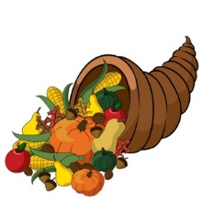
The history of Thanksgiving Day as we know it was begun by the early settlers that arrived in America around 1620. According to the World Book Encyclopedia, one of the first Thanksgiving observances in America was entirely religious and did not involve feasting. Later, people gave thanks with feasting and prayer for the blessings they had received during the year, it was an occasion to thank God for their plentiful crops.

In 1621, Massachusetts Governor William Bradford declared a Day of Thanksgiving for the purpose of prayer and celebration. Neighboring Indians were invited to the feast, as without their help the settlers would likely have perished. President Abraham Lincoln proclaimed the last Thursday in November 1863 as “a day of thanksgiving and praise to our beneficent Father.”
In the United States, Thanksgiving Day is usually a family day celebrated with big dinners and joyous reunions. It is also a time for serious religious refection, worship and prayer.

Thanksgiving Day is clearly not a biblically commanded day of celebration and feasting; however, Thanksgiving Day is certainly based on the biblical principle of being thankful to God for all of the wonderful blessings he has showered down on us. As individual Christians, we can follow the Traditions of our forefathers and enjoy family and friends on this special day, but in response to God’s goodness and his continued blessings let’s express our thankfulness every day for what our “beneficent Father” has done for us, especially the giving of his Son for the forgiveness of our sins!

As Paul said in I Thessalonians 5:16-18, “Rejoice always, pray without ceasing, give thanks in all circumstances; for this is the will of God in Christ Jesus for you” (ESV). – By David Coleman

